|  |
| --- |
| 新东方在线英语学习 |
| 新概念 2 册 |
| Lesson21 |



扫一扫。更多有趣的英语资讯。

## Lesson 21 单词讲解

1. mad adj. 发疯

I know I was wrong. Please don’t be mad at me. go mad 变疯了

drive sb. Mad 把某人逼疯

His behavior really drives me mad. drive drove driven

1. reason n. 原因

for some reasons for some reason

for one reason or another reasonable adj. 合理的unreasonable adj.

1. sum n. 量

a large sum of money to sum up 总之

1. determined adj. 坚定的，下定决心的

be determined to do sth.

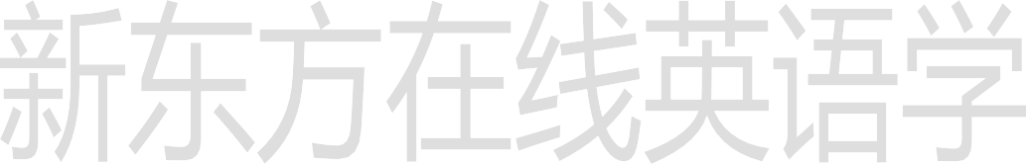He is determined to go abroad for further education. We are determined to hold on to the last.

**Lesson 21 课文&语法讲解**

# 本课重点

被动语态

与时态情态相结合

doing/done 修饰名词，（分词）作定语

1. passing planes can be heard night and day.

被动语态

be + done

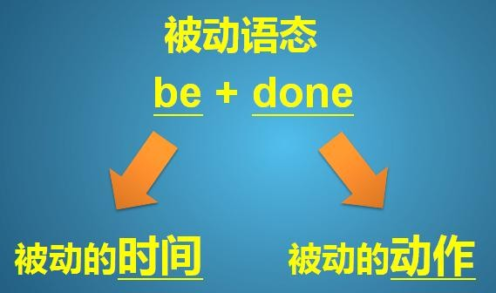



被动语态 be + done

他每天被打。 He is beaten every day.

他昨天被打了。 He was beaten yesterday.

他明天将要被打。 He will be beaten tomorrow.

他现在正在被打。 He is being beaten.



被动语态 be + done

他每天被打。 He is beaten every day.

他昨天被打了。 He was beaten yesterday.

他明天将要被打。 He will be beaten tomorrow.

他现在正在被打。 He is being beaten.



他现在已经被打了。 He has been beaten.

被动语态 be + done

* Our morning paper is read (read) by over 200,000 people every day.
* Last night my favourite TV program was interrupted (interrupt) by a special news bulletin.



被动语态 be + done

* His bike will be repaired (repair) by his grandfather tomorrow.
* The new machine has been used（use）in our factory for two weeks.

被动语态 be + done Planes are heard.

Planes can be heard.

Planes could be heard.

Planes may be heard.

Planes must be heard.

* The letter must be sent immediately.



被动语态

be + done

·这封信必须马上寄出。

* 天气不能被人们所控制。
* The weather cannot be controlled by people.

被动语态 be + done

·西红柿可以做菜或是生吃。

* Tomatoes may be cooked or eaten raw.

·我的钥匙肯定落在什么地方了。

* My keys must be left somewhere.

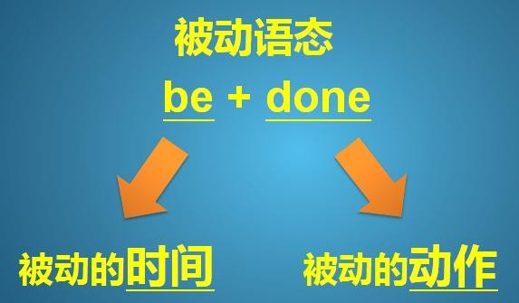

1. ... passing planes can be heard ...
2. The airport was built ... but ... it could not be used then.

Come into 投入到某种状态

1. Over a hundred people must have been driven away ... by the noise.



must have v.过去分词

be done

= must have been done

推测 过去 的被动

3. Over a hundred people must have been driven away ... by the noise.

must have been done 推测 过去 的被动

My cell phone must have been stolen. His keys must have been lost.

... the wallet must have been found by one of the villagers ...

1. Over a hundred people must have been driven away ... by the noise.
2. this house will be knocked down by a passing plane.
3. I have been offered ... money ...

* passing planes doing 修饰名词，作定语

# a waiting car

* a sleeping baby
* boiling water
* a developing country
* a woman wearing a white coat
* used cars done 修饰名词，作定语

# wasted time

* a deserted car park
* a ploughed field
* a developed country



* a car called Blue Bird
* the few people left

doing/done 修饰名词（分词作定语）

* ... passing planes can be heard night and day.
* I am one of the few people left.

## Lesson 21 知识拓展

**Key structure:**

**被动语态**

**与时态相结合**

被动语态 be + done

他每天被打。 他昨天被打了。

他明天将要被打。 他现在正在被打。 他现在已经被打了。

The letters for the boss on his desk but he didn’t read them until three days later.

* 1. were put
  2. was put
  3. put
  4. has put (2012 天津 2)

The letters for the boss on his desk but he didn’t read them until three days later.

1. were put
2. was put
3. put
4. has put (2012 天津 2)
   * Have you heard about the fire in the market?
   * Yes, fortunately no one .
5. hurt
6. was hurt
7. has hurt
8. had been hurt (2012 北京 29)

The way the guests in the hotel influenced their evaluation of the service.

A. treated



1. were treated
2. would treat
3. would be treated (2009 北京 27)

Don’t worry. The hard work that you do now later in life.

1. will be repaid
2. was being repaid
3. has been repaid
4. was repaid (2012 湖南 22)

Don’t worry. The hard work that you do now later in life.

1. will be repaid
2. was being repaid
3. has been repaid
4. was repaid (2012 湖南 22)

After school we went to the reading-room to do some reading, only to be told that it .

1. was decorated
2. had decorated
3. had been decorating
4. was being decorated (2012 安徽 35)

They are living with their parents for the moment because their own house .

1. is being rebuilt
2. has been rebuilt
3. is rebuilt
4. has rebuilt (2012 四川 11)

They are living with their parents for the moment because their own house .

1. is being rebuilt
2. has been rebuilt
3. is rebuilt
4. has rebuilt (2012 四川 11)

In the last few years thousands of films all over the world.

1. have produced
2. have been produced
3. are producing
4. are being produced (2011 天津 3)

I like these English songs and they many times on the radio.

1. taught
2. have taught



1. are taught
2. have been taught (2008 安徽 33)

I like these English songs and they many times on the radio.

1. taught
2. have taught
3. are taught
4. have been taught (2008 安徽 33)